Lab # 1 — Assessment Worksheet

**Course Name and Number: FRS301**

**Student Name: Tran Thanh Tuan**

**Student Id: SE161095**

**Instructor Name: Nguyen Van Vinh**

# **Using HexView to view header about JPEG, EXE to understanding FILE HEADER**

***Opening the Trid and HxD for identify and view header image file***

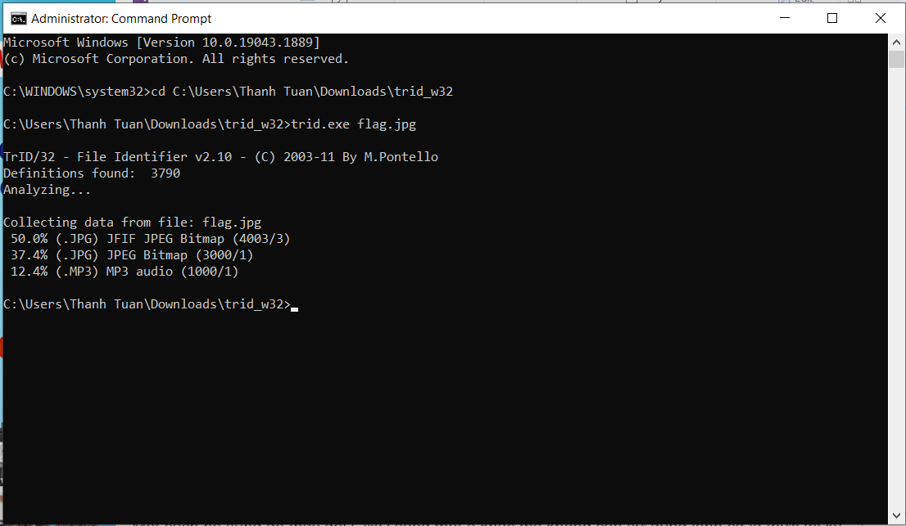

***View header JPEG by HexView***

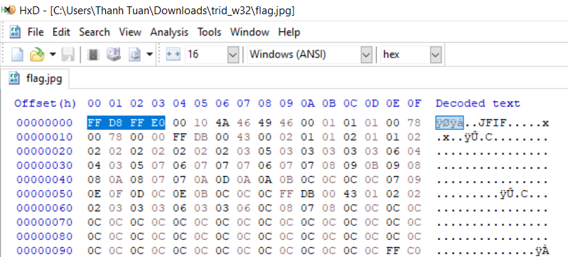

***Mofify FF-D8-FF-E1 to FF-D8-FF-E2 you can not see the picture***

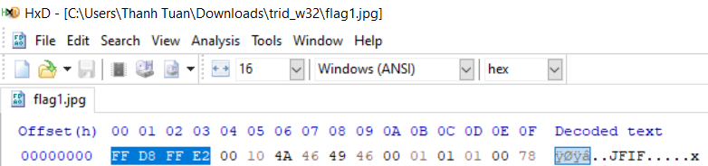

***Trid identifies the flag file***

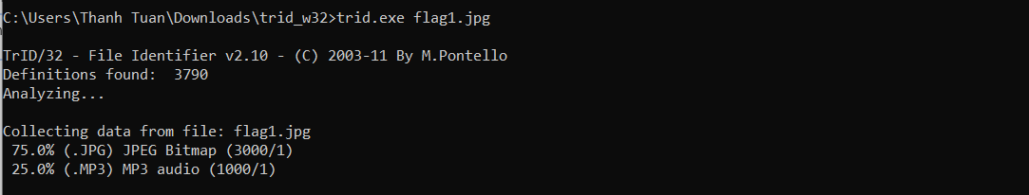

# **Rebuilding an Image Header**

***Downloading the Image File***

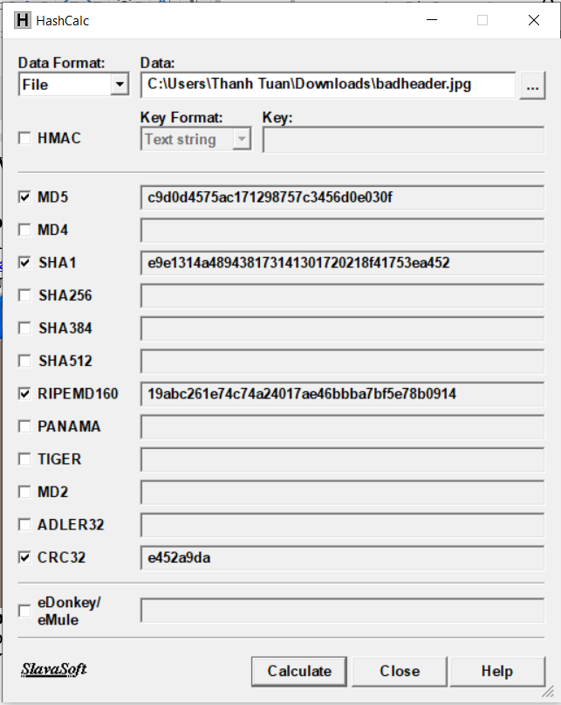

***Opening the Image File***

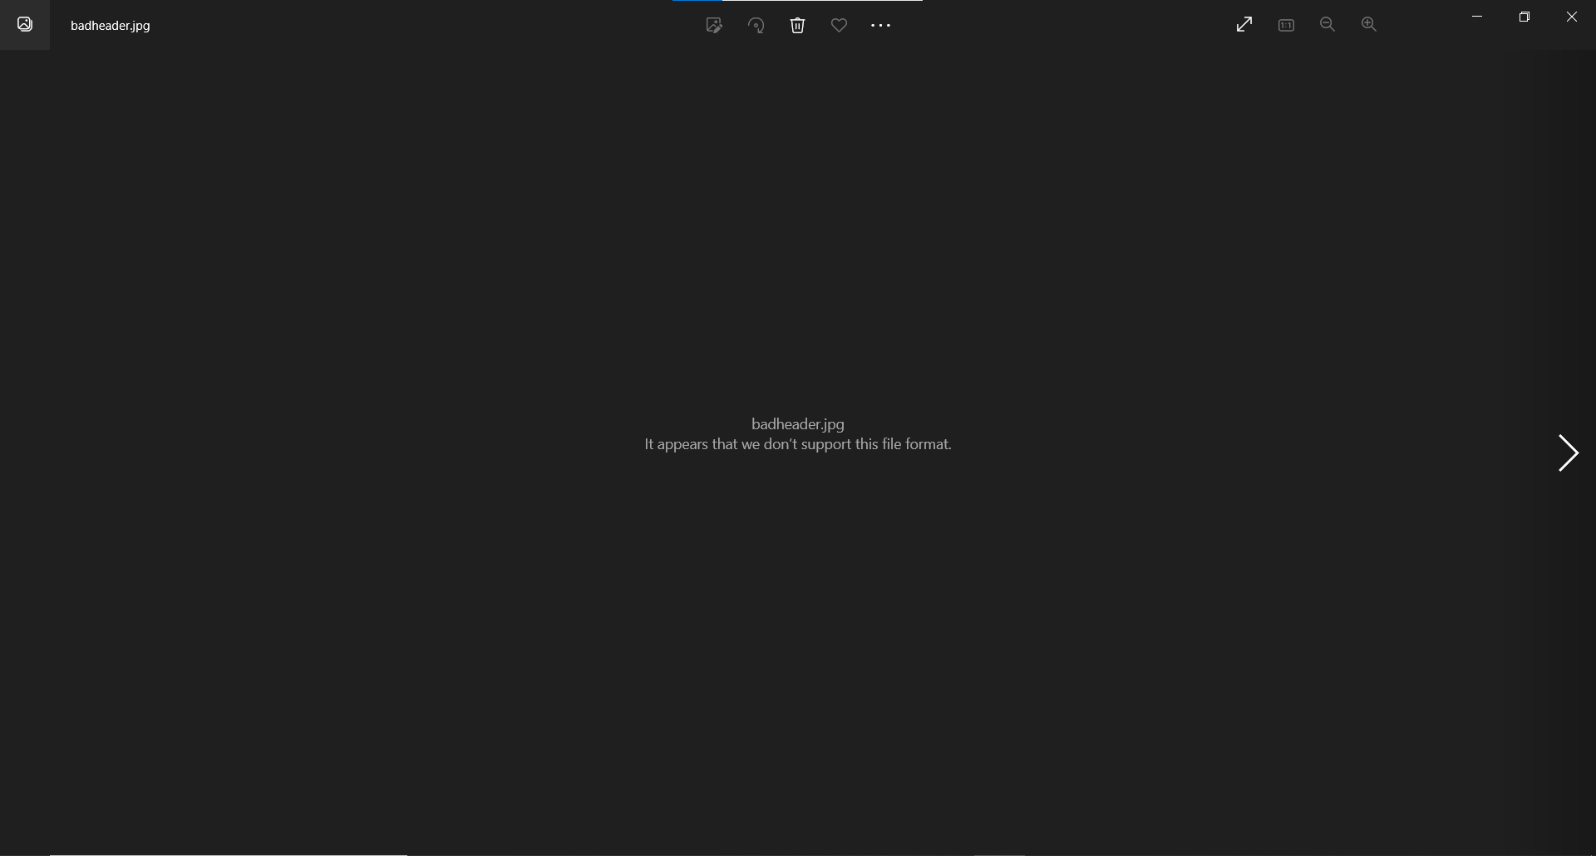

***Viewing the File in a Hex Editor***

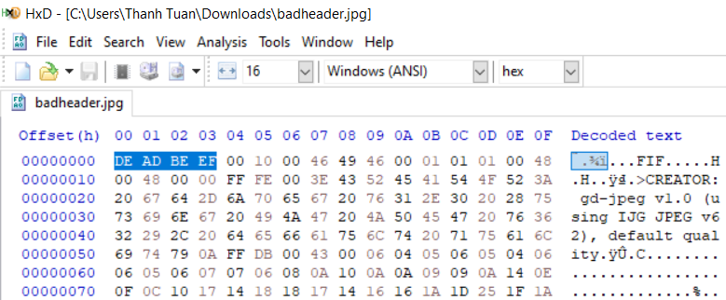

***Examining a Good JPG File***

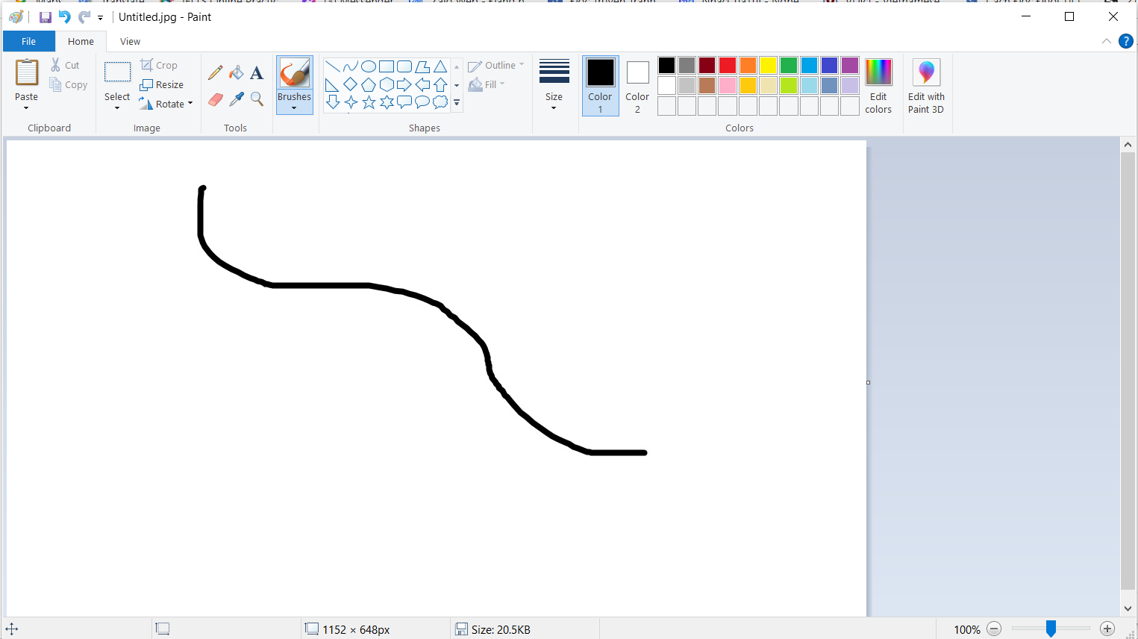

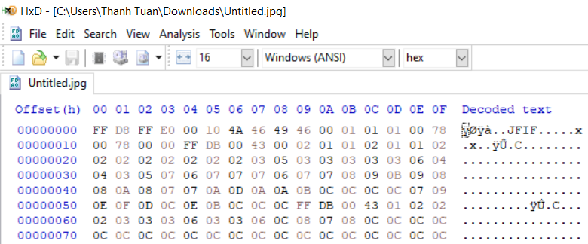

***Repairing the Header***

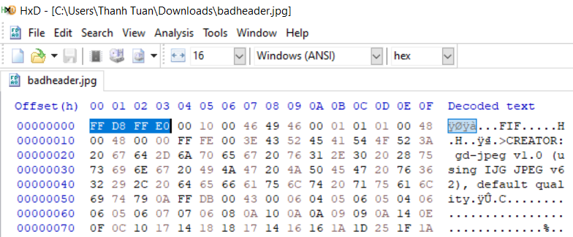

***Viewing the Image***

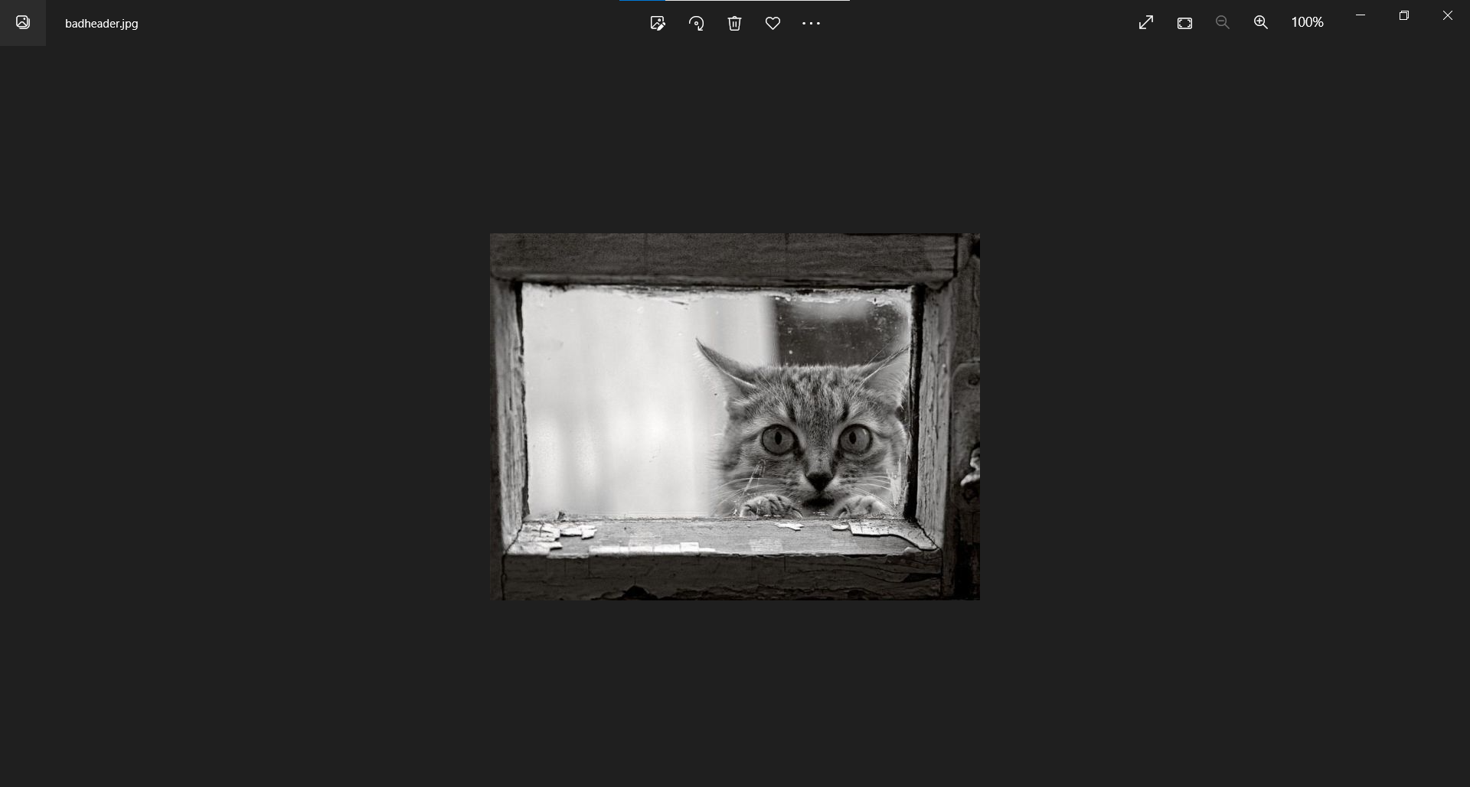

***Saving a Screen Image***

